## Contents

***TOPICS PAGE NO.***

|  |  |  |
| --- | --- | --- |
| 1. Abstract |  | 1 |
| 2. Introduction |  | 1 |
| 3. Purpose |  | 1 |
| 4. Modules |  | 2 |
| 5. Advantage |  | 2 |
| 6. Disadvantage |  | 2 |
| 7. Feasibility Study |  | 3 |
| 8. Project Category: Web Based Application |  | 4 |
| 9. Use Case Diagram |  | 5 |
| 10. Sequence Diagram |  | 6 |
| 11. Data Flow Diagram(DFD) |  | 7 |
| 12. Entity Relationship Diagram |  | 8 |
| 13. User Interface Snapshots |  | 9-13 |
| 14. Database Tables |  | 14-18 |
| 15. Sample Codes |  | 19-30 |
| 16. Features of Restaurant Management System |  | 31 |
| 17. Future Scope Of this Work |  | 31 |
| 18. Conclusion |  | 31 |
| 19. Bibliography |  | 32 |

### **Abstract:**

### Customer satisfaction is the key to success for any business. In a restaurant, the traditional hand-waving method for calling services is inefficient often leading to many complaints. The **Restaurant Management System** increases operational efficiency through use of an internal wired communications system. The communications system increases customer satisfaction by leaving a system at each table which the customer can use to request for a server. This system allows managers and owners to easily monitor restaurant functions and employee progress.

### In many popular restaurants, waiters/waitresses tend to miss out on tables or customers’ calls during busy hours potentially decreasing ones clientele. While this is an ongoing issue, there is still no product that drastically improves the communication between the servers and the customers in the current market. Hence, the goal is to design a system in which the customers can call their servers easily and help the restaurant increase overall efficiency.

### **Introduction**

In many popular restaurants, waiters/waitresses tend to miss out on tables or customers’ calls during busy hours potentially decreasing ones clientele. While this is an ongoing issue, there is still no product that drastically improves the communication between the servers and the customers in the current market. Hence, the goal is to design a system in which the customers can call their servers easily and help the restaurant increase overall efficiency. An internal wired communication system will allow prompt notification to the server when a customer requires service. Moreover, servers can also be more focused on serving their current customers and save their time and energy from always keeping an eye out for needy customers.

On top of meeting the needs of customers, restaurant managers can also monitor the response time of their waiters/waitresses through use of this system. Hardworking, proficient employees will become more recognized while lazy, inefficient employees become motivated to improve. As a result, the restaurant becomes more efficient and possibly increasing morale while improving the level of customer satisfaction.

**Purpose**

Now a day, the world is getting into digital world. System was trying to build out to make people even more convenience on any aspects. Restaurant Management System provide an system based food ordering system without help of a waiter. It involves seller and buyer which could bring benefits to each other. It is win-win situation that will bring benefits to the world. This system was bringing a convenience for customer that can make order by help of a computer.

It provides customer with a completely new way to make order. By providing customer convenience and also increase the sales. No time wasted with order taking or letting the customer browse the menu over the system.

This system provides more reliable usability, maintainability and dependability functions. By creating quality, easy to keep track management of new system. So that it can streamline all the works by a simple click. By develop the system based food ordering system can reduce the unnecessary costs such as staff salaries, customer satisfaction, reputation, etc. Our restaurant also easy to keep track for the maintenance and point redemption.

**Modules:**

**Admin**

The Admin gets logged in by valid username and G-mail. Admin can add new Menu Item and get Bill according to his menu. Admin can set the ‘Table’ and ‘Time’ for his meals.

### **Advantages**

* It is cost effective as the user control the web application himself and does not go out in market their meals.
* It saves Customer’s Time.
* They can get meals easily, which is not available in this area.
* The software is easy to use and is user friendly so no expertise is required.
* The calculations are automated so no chance of error.

### **Disadvantages**

* It requires an internet connection.
* It requires large database.

**FEASIBILITY STUDY**

After identifying the scope of the project, the feasibility study is needed to be carried out. It is basically keeping the following points in mind.

**Building the software for meeting the scope:** This software has met the scope. As there is no data involved in the system, processing on the file, and the behaviour of this project is already identified and bundled in quantitative manner.

The processing of this software is very simple as it has been designed in java and it has been well divided into several functions according to the need.

**Technically feasible:** This software is very much technically feasible. This software is very much concerned with specifying equipment and the software will successfully satisfy almost all the admin’s & customer’s requirements. The technical need for this system may vary considerably but might include:

1. The facility provide order in any time.
2. Response time under certain conditions.
3. Ability to process data at a particular speed.

Therefore, the basic input/output of data is identified. So, the project can easily be build up and it will also be technically feasible.

**State of Art:** The project is very much within the state of art since the project is a WINDOWS based; it uses very modern and common technique.

Beside it is very much modern and user friendly. It also works as middleware i.e. only in between the coustmer’s and the file. So, it is completely a state of art project.

**Financially Feasible:** The project is very much financially feasible. The implementation and development cost of this software under the reach of any person’s.

# Project Category: Web-Based Application

#### Available Technologies:

**Languages**:

* HTML
* CSS
* JavaScript
* RDBMS:
* My SQL

**Web Server:** WAMP server

**Development Platform:** Visual Studio Code.

#### Tools Used:

Editor Used: Eclipse for java, WAMP server for MySQL Operating System: Windows 11.

#### Hardware Used:

Processor: Intel core i3 RAM: 8GB

Hard Disk: 1TB

**Use Case Diagram:**

No (Wrong user name/G-mail)

Member Validate info

Yes

Successful Registration

Registration fails

Validate Use

jjj

Entity Relationship Diagram(ERD)

My Discription SQL

**Customer Info**

This table keeps the record of the customer’s information before user logs on he fills up a form that guides him how he can become a member. Email ID is primary key in this table so we can recognize each member’s email ID uniquely as it is used as their user ID as well. Other information includes customer Name, password, contact no, Address and status, the later tells him about whether the member is blacklisted or locked. The entity shares a 1:N Relation with order utilities.

**Menu:**

The name insists, it contains the information of all menus and its related matter. Each menu is uniquely identified by its Item ID (Primary key). The purpose here is to provide customers all the information regarding menu such as Name (item), Description, Category, price and status (to check customer, whether that item is currently available or Not!!). Later, at the management’s point of view, we provide user ID (uniquely selected by management staff) to alter the contents of table. This entity shares N:1 relationship with the ordered item entity.

**Ordered** **Item:**

This table provides information to the management staff regarding the uniquely generated order ID, which may contain one or more menu item uniquely identified by Item ID. Apart from this, the management can check/alter the status of the order along with, they can alter the cook/s which was previously assigned to fulfill the order, this can be done by the management staff by logging in with User ID. A cook can place status over this entity regarding the status of the specified item is ready for delivery or not !!, this is done by using uniquely provided cook ID. From customer’s perspective, customer can check the status of his order in detail i.e. the status of each item in his order from this table as well as the quantity he ordered, the later can also be helpful at the management side. This entity shares 1: N relationship with the Menu table.

**Order**

This table tells about the Order ID (which is a primary key), who has placed the order and gives details about the time when order was placed and the time when the order will be delivered; along with the status of the order (usually some 5 status labels are assigned). This table shares N:1 relationship.

Data Directory

**Table Name: Admin**

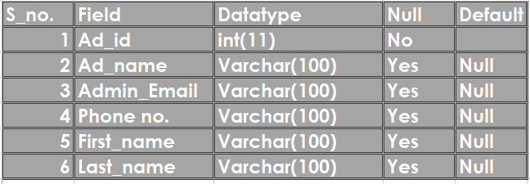

**Table Name Category:**

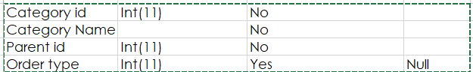

**Table name Customer:**

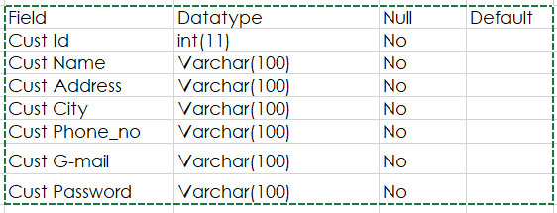

**Table name Order:**

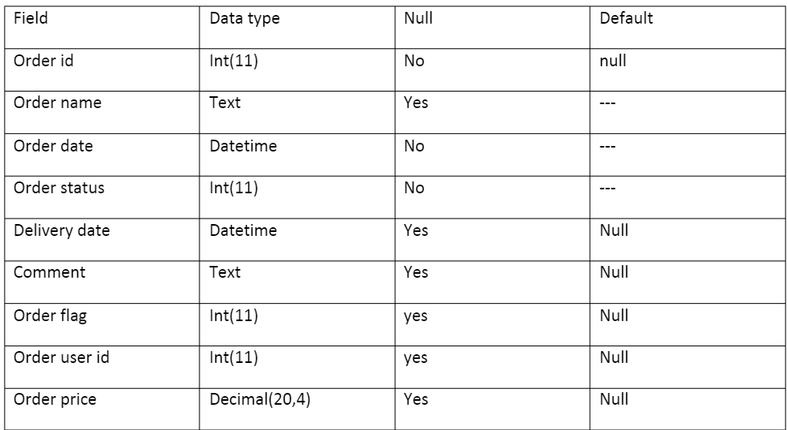

**Table Name Payment:**

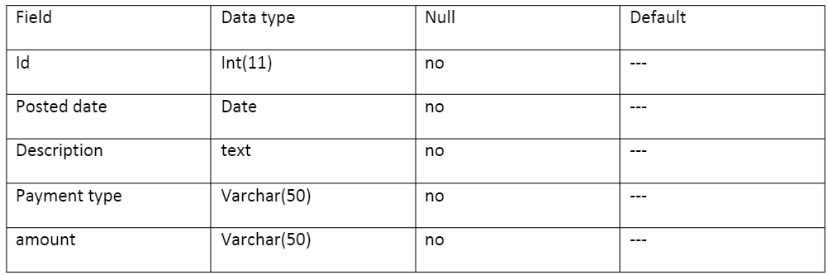

**Screenshots**

**Front Page:**

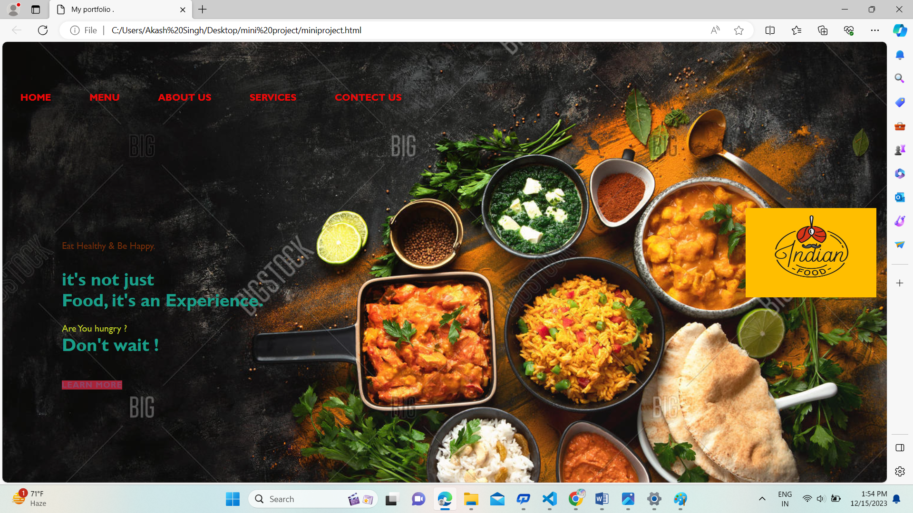

**Menu page:**

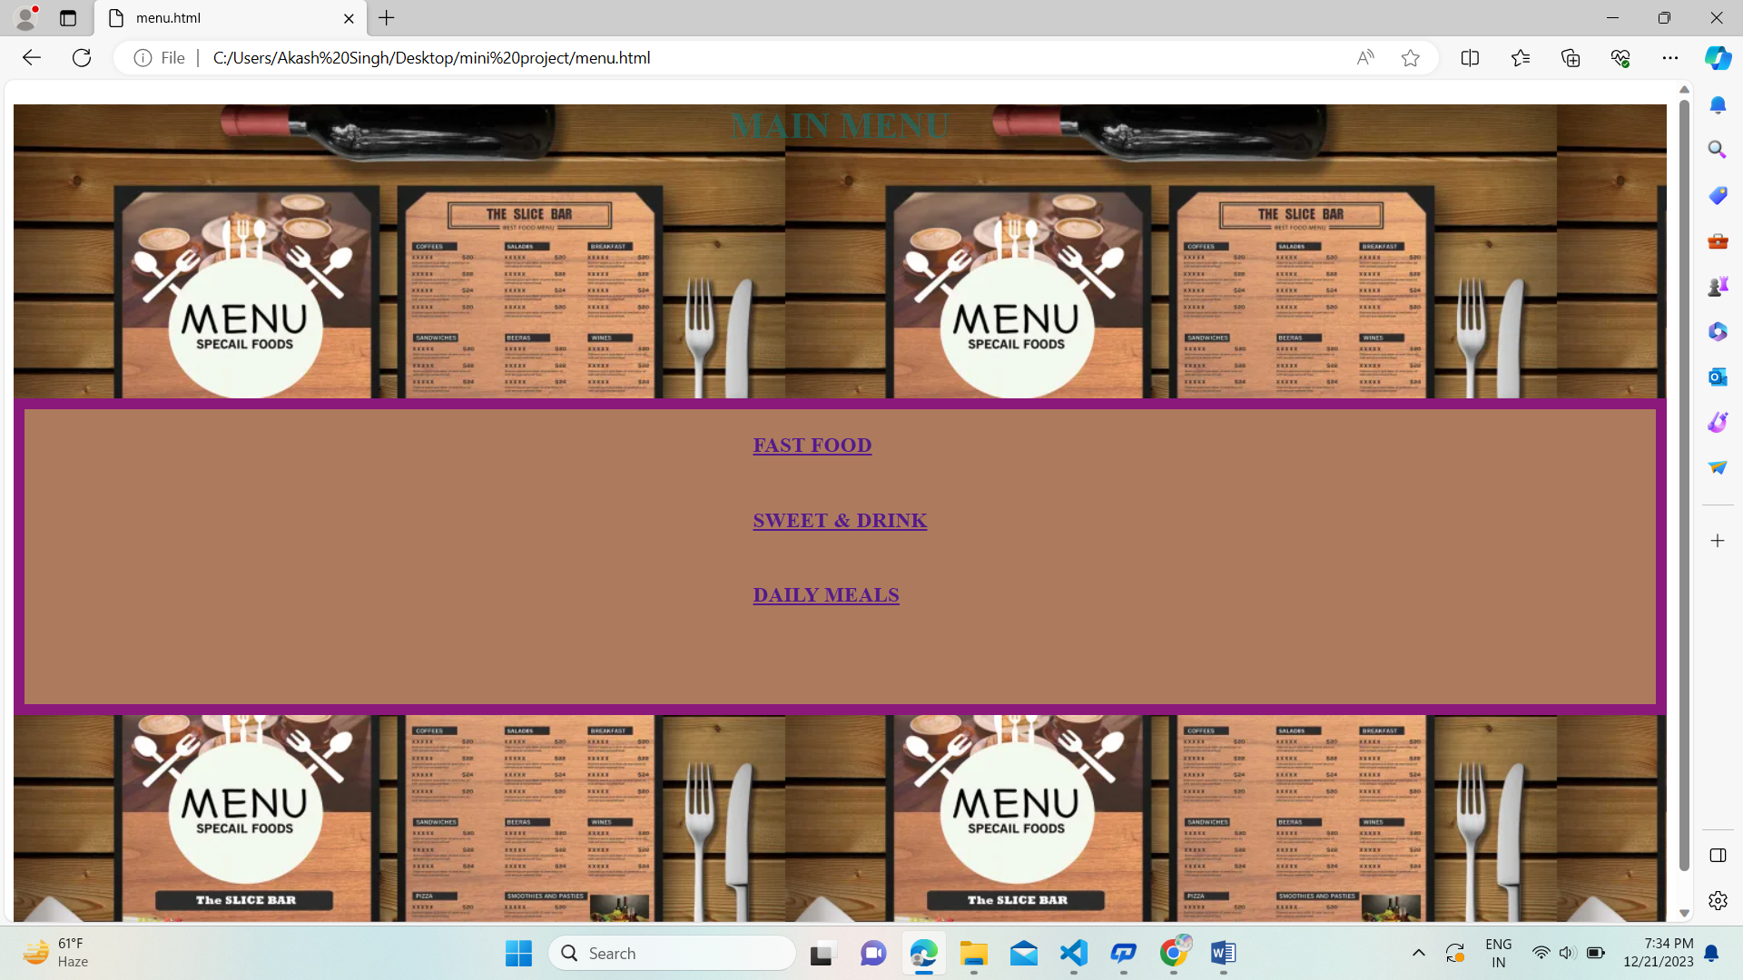

**Login_Page:**

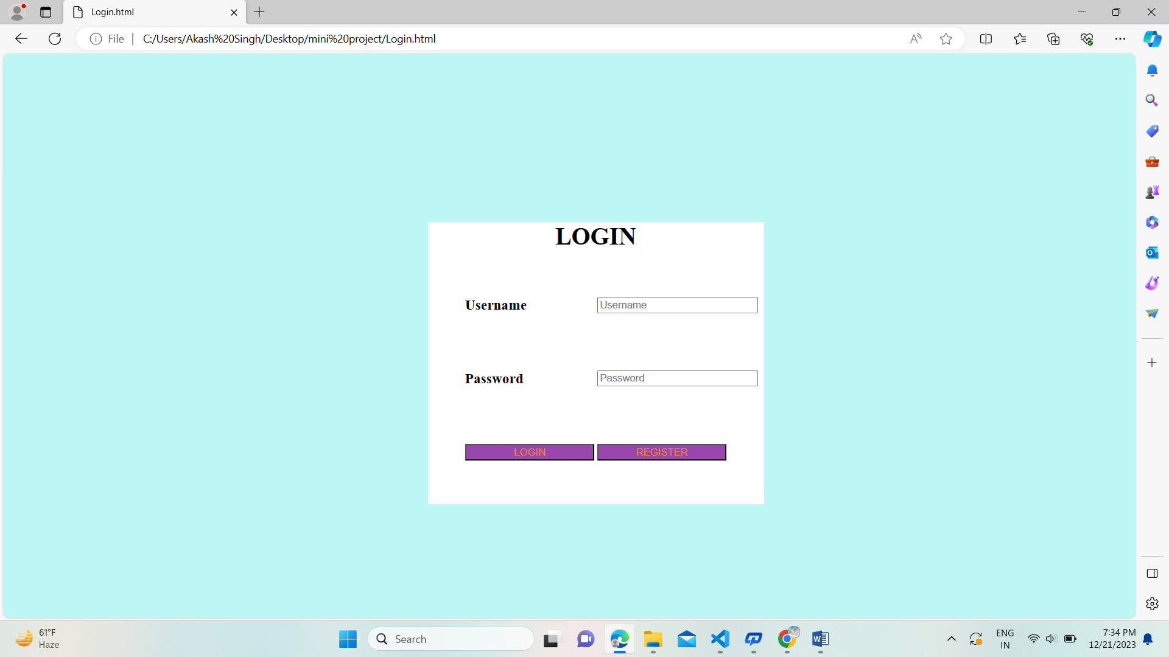

**Fast Food:**

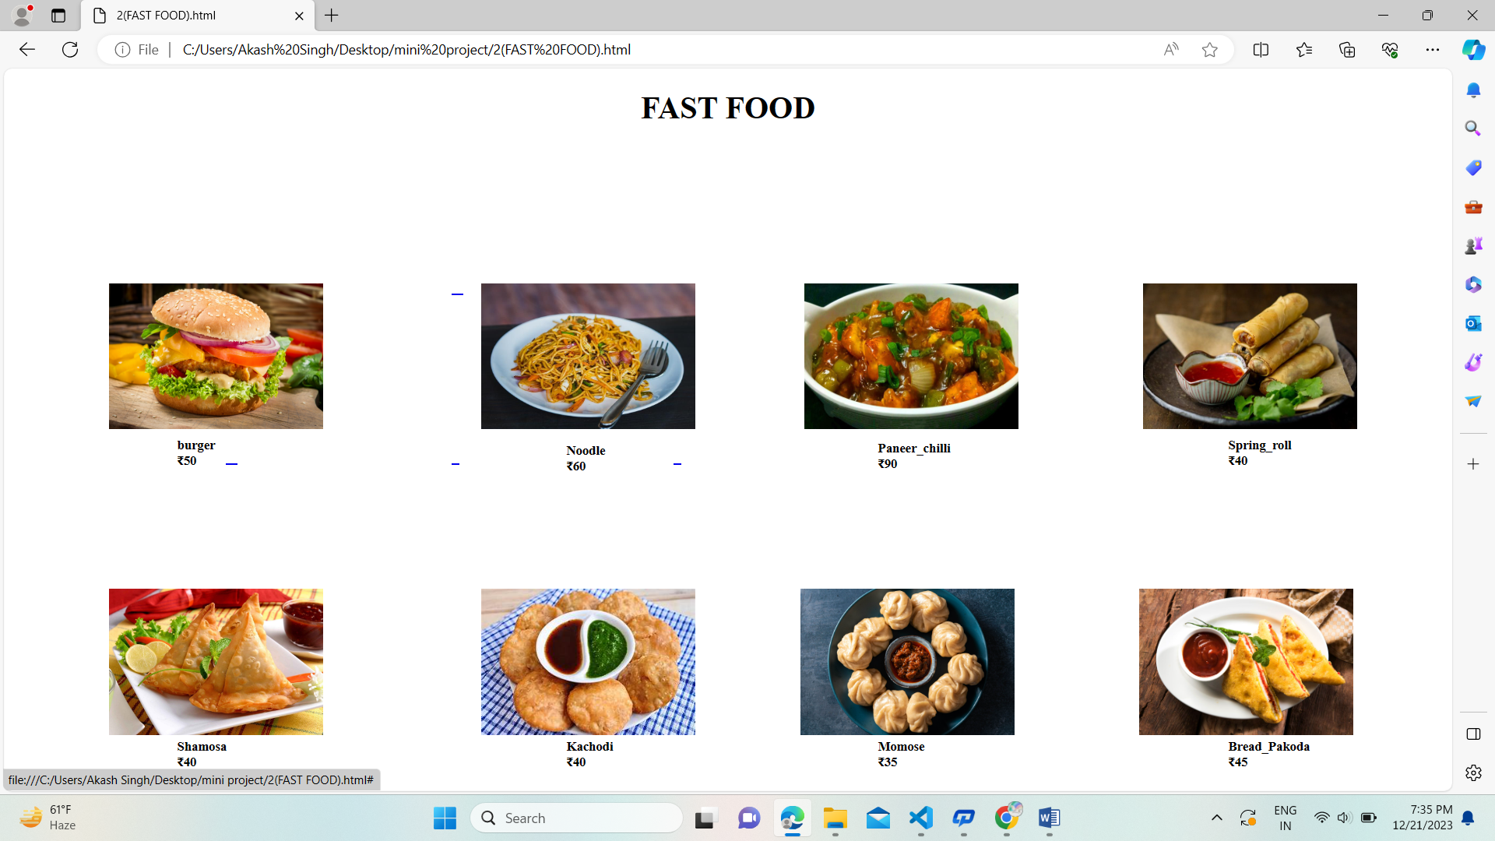

**Sweet & Drink’s:**

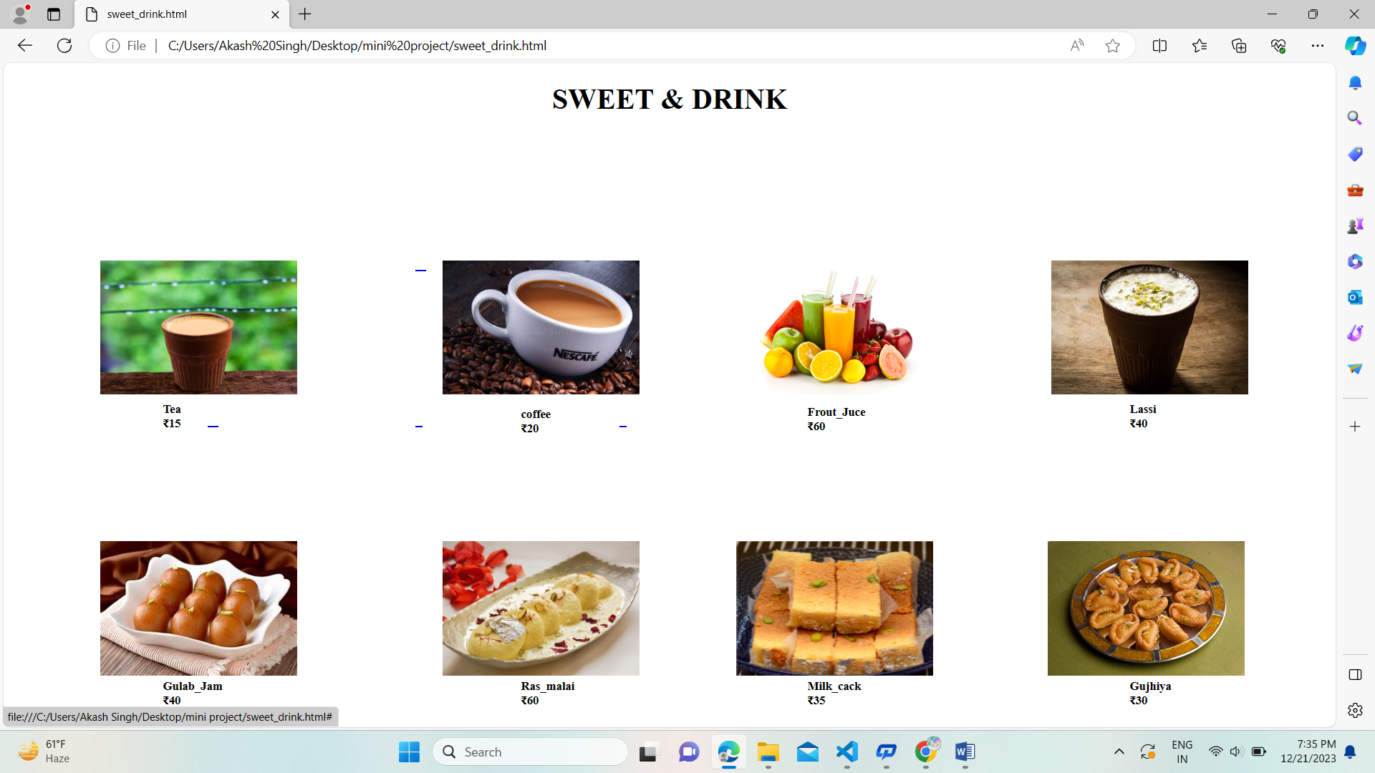

**Daily Meals:**

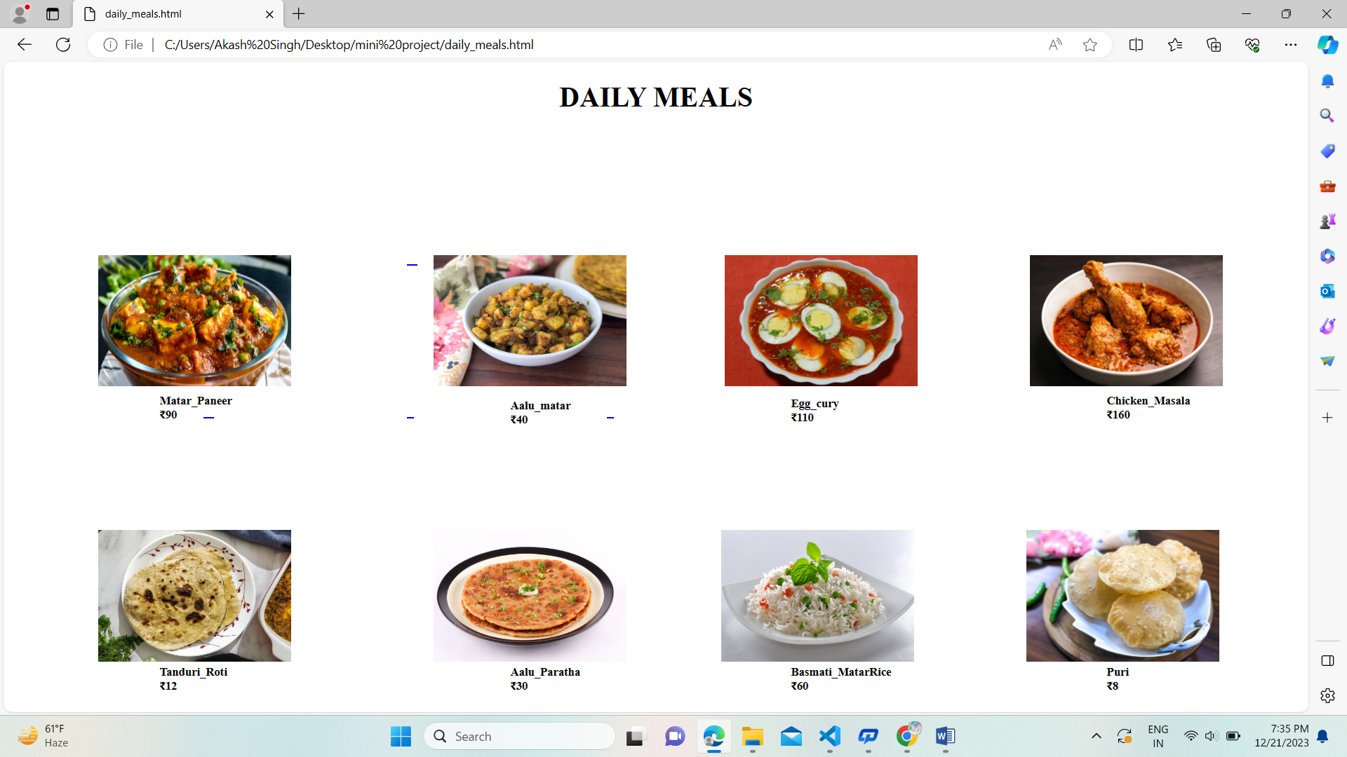

**Source** **Code:**

<!DOCTYPE html>

<html>

<head>

<title>

My portfolio .

</title>

<meta name="viewport" content="width=device-width" ,initial-scale="1.0">

<link rel="stylesheet" href=" ">

<style>

*{

margin:0;

padding:0;

font-family: 'Gill Sans', 'Gill Sans MT', Calibri, 'Trebuchet MS', sans-serif;

}

.header{

width:100%;

height:100vh;

background-color:rgb(24, 167, 228);

background-image: url('food.jpg');

}

.nav{

display:flex;

margin:auto;

width:100%;

padding:20px;

align-items:center;

justify-content: space-between;

}

nav ul li{

display:inline-block;

list-style: none;

margin:30px;

top:150px;

}

nav ul li a{

text-decoration: none;

color:rgb(236, 8, 8);

font-weight: bolder;

}

nav ul li a:hover{

background-color:steelblue;

border-radius: 2px;

color:bisque;

}

.button-CV,.Button-gfc{

display:inline-block;

margin-left: 0%;

border-radius: 5px;

transition: background-color 0.5s;

background-color: black;

padding:10px;

text-decoration: none;

font-weight: bold;

color:rgb(209, 132, 17);

border:none;

cursor:pointer;

}

.button-cv:hover{

background-color: rgb(197, 128, 38);

color:black;

}

.button-gfc{

background-color: yellowgreen;

}

.button-gfc:hover{

background-color: rgb(35, 206, 206);

color:black;

}

.body{

margin-left: 100px;

margin-top:100px ;

}

.body h1{

font-size: 30px;

color:rgb(26, 159, 137);

margin-bottom: 20px;

}

.demo1{

color:rgb(113, 45, 9);

margin-bottom: 30px;

}

.demo2{

color:rgb(191, 205, 42);

line-height:20px;

}

.button-lrn,.button-hire{

background:rgb(168, 35, 55);

padding:10px ,12px;

text-decoration: none;

font-weight: bold;

color:rgb(140, 69, 103);

display:inline-block;

margin:30px,8px;

transition: background-color 0.3s;

border:none;

letter-spacing: 1px;

cursor:pointer;

}

.button-lrn:hover{

background-color: purple;

color:black;

}

.button-hire{

background-color: rgb(212, 14, 186);

}

.button-hire:hover{

background-color: yellow;

}

.span{

color:aqua;

}

.image img{

height: 70px;

position:absolute;

right:150%;

bottom:10%;

transform:translate(-60%) ;

}

.imge{

height:100%;

width:45%;

position:absolute;

bottom:0;

right:100px;

background-image: -moz-element(100px);

}

</style>

</head>

<body >

<div class="main-container" img src="th.jpeg" >

<div class="header" >

<nav>

<a href="#"><img src="i.jpg" alt="logo" height="150px"width="220px" style="position:relative;left:1250px;right:70px;top:280px; background-color:azure;"></a>

<ul style="position:relative;bottom:100px;">

<li><a href="#">HOME</a></li>

<li><a href="menu.html">MENU</a>

</li>

<li><a href="#">ABOUT US</a></li>

<li><a href="#">SERVICES</a></li>

<li><a href="#">CONTECT US</a></li>

<!-- <li><button type="button" class="button-gfc">Get Free Consultant and advice</button></li>

<li><button type="button" class="button-cv">DOWNLOAD CV</button></li> -->

</ul>

</nav>

<div class="body" >

<p class="demo1">Eat Healthy & Be Happy.</p>

<h1>it's not just<br>Food, it's an <span> Experience.</span></h1>

<p class="demo2">Are You hungry ?<br><h1>Don't wait !</h1> <br></p>

<button type="button" class="button-lrn">LEARN MORE</button>

<!--- <button type="button-hire">HIRE ME</button> -->

</div>

<div class="image">

<img src="th.jpeg">

</div>

</div>

</div>

</body>

</html>

Fast Food:

<!DOCTYPE html>

<html>

<head>

</head>

<body>

<div class="mane_container">

<center><h1>FAST FOOD</h1></center>

<div class="container1">

<a href="#"><img src="4.jpg " alt="logo" height="150px" width="220px" style="position:relative; left:100px;top:140px;gackground-color:orange">

&nbsp;&nbsp;<img src= "7.jpg" alt="logo" height="150px" width="220px" style="position:relative;left:250px;top:140px">

&nbsp;&nbsp;<img src= "8.jpg" alt="logo" height="150px" width="220px" style="position:relative;left:350px;top:140px">&nbsp;&nbsp;<img src="r.jpg" alt="logo"

height="150px" width="220px" style="position:relative;left:470px;top:140px"></a>

</div>

<div class="container2">

<a href="#"><img src="Sam.jpg" alt="logo" height="150px" width="220px" style="position:relative; left:100px;top:280px">&nbsp;&nbsp;

<img src="th (2).jpeg" alt="logo" height="150" width="220px" style="position:relative;left: 250px;top:280px">&nbsp;&nbsp;<img src="st.jpg"alt="logo" height="150px"width="220px"style="position:relative;

left:350px;top:280px">&nbsp;&nbsp;<img src="y.jpg" alt="logo" height="150px" width="220px" style="position:relative;left:470px;top:280px"></a>

</div>

<div class="container3">

</div>

</div>

</body>

</html>

Sweet & Drink

<!DOCTYPE html>

<html>

<head>

<style>

.h3{

position:relative;

top:220px;

left:300px;

}

</style>

</head>

<body>

<div class="mane_container">

<center><h1>SWEET & DRINK</h1></center>

<div class="container1">

<a href="#"><img src="tea.webp" alt="logo" height="150px" width="220px" style="position:relative; left:100px;top:140px;gackground-color:orange">

&nbsp;&nbsp;<img src= "cof.jpg" alt="logo" height="150px" width="220px" style="position:relative;left:250px;top:140px">

&nbsp;&nbsp;<img src= "frout.jpg" alt="logo" height="150px" width="220px" style="position:relative;left:350px;top:140px">&nbsp;&nbsp;<img src="lassi.jpg" alt="logo"

height="150px" width="220px" style="position:relative;left:470px;top:140px"></a>

</div>

<div class="container2">

<a href="#"><img src="jam.jpg" alt="logo" height="150px" width="220px" style="position:relative; left:100px;top:280px">&nbsp;&nbsp;

<img src="Rasmalai.jpeg" alt="logo" height="150" width="220px" style="position:relative;left: 250px;top:280px">&nbsp;&nbsp;<img src="CAKE.jpg"alt="logo" height="150px"width="220px"style="position:relative;

left:350px;top:280px">&nbsp;&nbsp;<img src="Gujiyas.jpg" alt="logo" height="150px" width="220px" style="position:relative;left:470px;top:280px"></a>

</div>

<div class="container3">

</div>

</div>

</body>

</html>

Daily meals:

<!DOCTYPE html>

<html>

<head>

</head>

<body>

<div class="mane_container">

<center><h1>DAILY MEALS</h1></center>

<div class="container1">

<a href="#"><img src="45.jpg " alt="logo" height="150px" width="220px" style="position:relative; left:100px;top:140px;gackground-color:orange">

&nbsp;&nbsp;<img src= "00.jpg" alt="logo" height="150px" width="220px" style="position:relative;left:250px;top:140px">

&nbsp;&nbsp;<img src= "egg.jpg" alt="logo" height="150px" width="220px" style="position:relative;left:350px;top:140px">&nbsp;&nbsp;<img src="cki.jpg" alt="logo"

height="150px" width="220px" style="position:relative;left:470px;top:140px"></a>

</div>

<div class="container2">

<a href="#"><img src="12.webp" alt="logo" height="150px" width="220px" style="position:relative; left:100px;top:280px">&nbsp;&nbsp;

<img src="23.jpg" alt="logo" height="150" width="220px" style="position:relative;left: 250px;top:280px">&nbsp;&nbsp;<img src="111.jpg"alt="logo" height="150px"width="220px"style="position:relative;

left:350px;top:280px">&nbsp;&nbsp;<img src="puri.jpg" alt="logo" height="150px" width="220px" style="position:relative;left:470px;top:280px"></a>

</div>

<div class="container3">

</div>

</div>

</body>

</html>

Feature of Resturant Management System:

* Easy to use.
* It is completely secure.
* It is completely controlled by admin.
* This system is easily compatible with most of the web browsers.
* It is very interactive and saves time.
* Reduces paper works.
* Calculations are automated so it is highly accurate.
* Admin can view all the records whenever necessary with ease.

Future scope of the work:

* The option to print the records In future.
* I intend to add a leave structure in the future.
* I would like to implement a regular backup mechanism to back up the employee database to avoid disasters.
* The system can be developed in such a way that its existing features can be modified to better versions.

Conclusion:

The purpose of the wireless restaurant management system is to

improve worker efficiency and to maximize profit margin of restaurant owners

by providing better service. Providing prompt response to customers through

use of a System and data collection by the Main Dispatcher will allow this to

happen. This project proved to be a larger task than expected due to lack of

manpower and late arriving parts. Certain functionality also had to be

abandoned to meet time constraints. The System is not designed to replace the

existing ordering systems which are at many restaurants but to complement it.

Once the Restaurant Management System becomes further refined with the

ideas discussed in the previous section, it will pose to be an indispensable tool

The purpose of the wireless restaurant management system is to

improve worker efficiency and to maximize profit margin of restaurant owners

by providing better service. Providing prompt response to customers through

use of a System and data collection by the Main Dispatcher will allow this to

happen. This project proved to be a larger task than expected due to lack of

manpower and late arriving parts. Certain functionality also had to be

abandoned to meet time constraints. The System is not designed to replace the

existing ordering systems which are at many restaurants but to complement it.

Once the Restaurant Management System becomes further refined with the

ideas discussed in the previous section, it will pose to be an indispensable tool

The purpose of the wireless restaurant management system is to

improve worker efficiency and to maximize profit margin of restaurant owners

by providing better service. Providing prompt response to customers through

use of a System and data collection by the Main Dispatcher will allow this to

happen. This project proved to be a larger task than expected due to lack of

manpower and late arriving parts. Certain functionality also had to be

abandoned to meet time constraints. The System is not designed to replace the

existing ordering systems which are at many restaurants but to complement it.

Once the Restaurant Management System becomes further refined with the

ideas discussed in the previous section, it will pose to be an indispensable tool

The purpose of the wireless restaurant management system is to improve worker efficiency and to maximize profit margin of restaurant owners by providing better service. Providing prompt response to customers through use of a System and data collection by the Main Dispatcher will allow this to happen. This project proved to be a larger task than expected due to lack of manpower and late arriving parts. Certain functionality also had to be abandoned to meet time constraints. The System is not designed to replace the existing ordering systems which are at many restaurants but to complement it. Once the Restaurant Management System becomes further refined with the ideas discussed in the previous section, it will pose to be an indispensable tool.